Large Language Models for Measurement and Automation
Guest lecture transcript for ECE 4433/5433, Measurement and Automation, taught by Dr. Sarah Sharif. Arash Ahmadi, INQUIRE Lab, The University of Oklahoma. Planned length: about 45 minutes plus questions. Times in brackets are targets for each slide.

Slide 1: Title [1 minute]
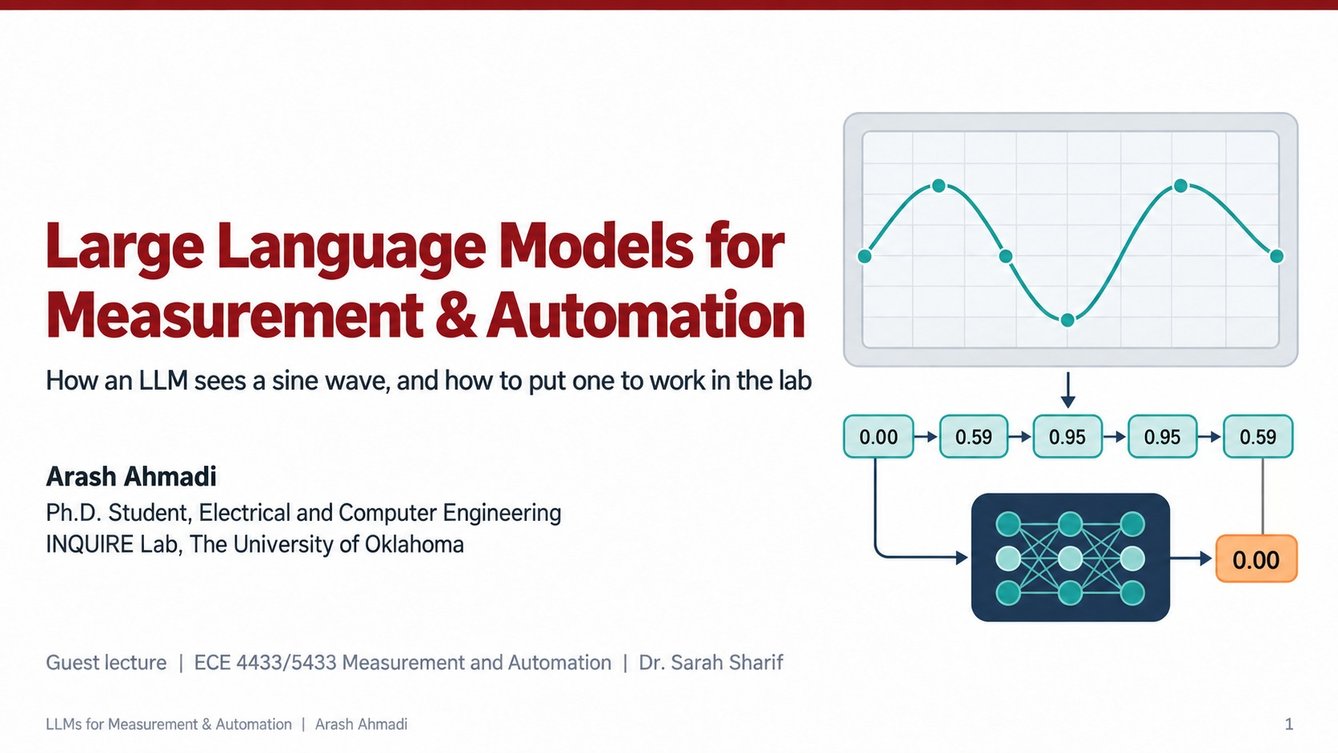
Good morning, everyone. My name is Arash Ahmadi. I am a PhD student in Electrical and Computer Engineering here at OU, and I work in the INQUIRE Lab, where most of my research is about training large language models and understanding what happens inside them. I want to thank Dr. Sharif for inviting me to Measurement and Automation today.
You have probably all used ChatGPT or something like it. Today I want to open the box. I will show you what a language model actually computes, with the real math, and then we will look at something I think fits this class very well: how one of these models sees a measurement. We will take a simple sine wave, the kind you see on an oscilloscope every week, and follow it all the way into the model. After that we will talk about how you can put these models to work next to your PLCs and your LabVIEW programs, without letting them break your instruments or invent your data.

Slide 2: Today's roadmap [1.5 minutes]
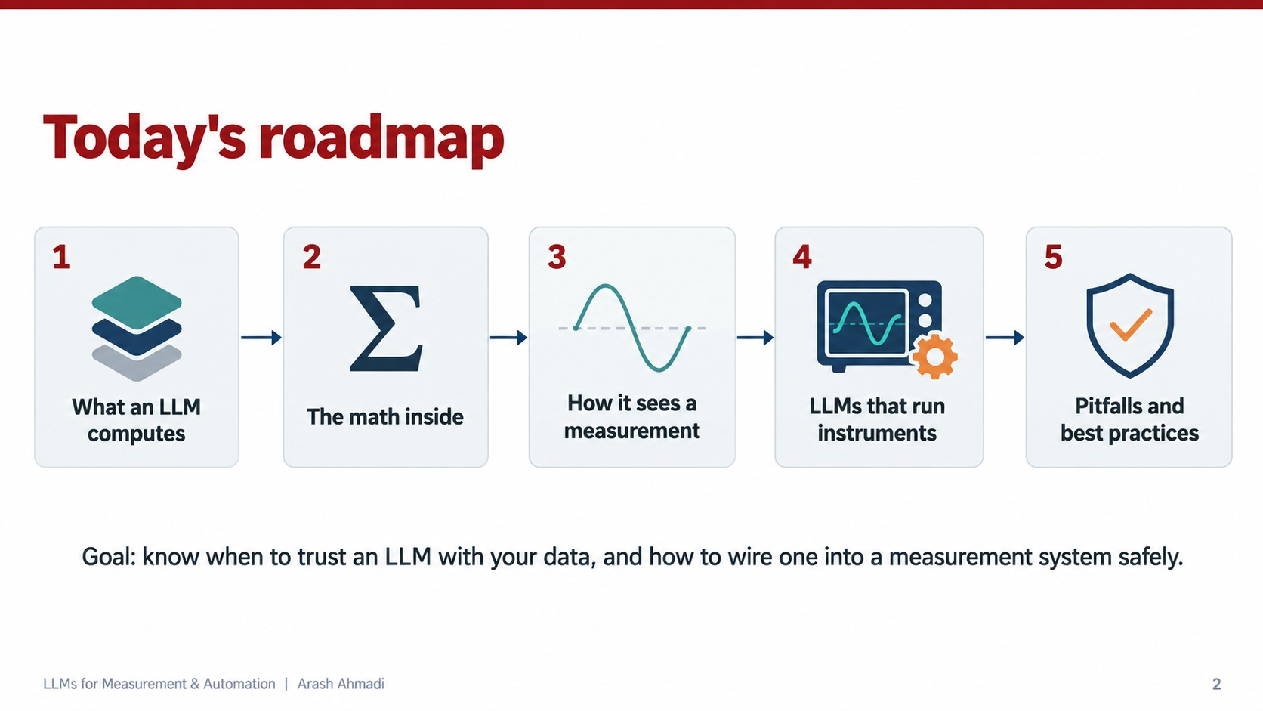
Here is the plan for the next forty five minutes. There are five steps.
First, what an LLM computes. The answer is surprisingly simple, and once you see it, a lot of the strange behavior of these models starts to make sense.
Second, the math inside. I will show you the three or four equations that almost every modern language model is built on. You do not need to memorize them, but you should see them once, because they explain everything else.
Third, how the model sees a measurement. This is the sine wave example.
Fourth, language models that run instruments. This is the automation part: a model that writes code, talks to a function generator and an oscilloscope, and reports back.
Fifth, pitfalls and good habits.
My goal is simple. At the end of today I want you to know when you can trust a language model with your data, when you cannot, and how to wire one into a measurement system safely.

Slide 3: An LLM is a next token predictor [3 minutes]
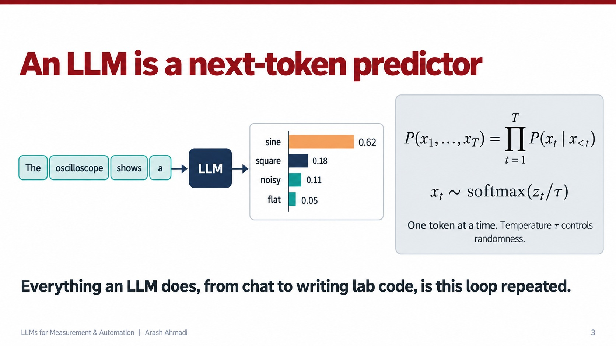
Let us start with the most important idea of the whole talk. A large language model does exactly one thing. It looks at some text and predicts what comes next. That is all.
Look at the example on the left. We give the model the words "The oscilloscope shows a" and ask for the next piece of text. The model does not give one answer. It gives a probability for every possible next word. Here it says "sine" with probability 0.62, "square" with 0.18, "noisy" with 0.11, and "flat" with 0.05. The pieces of text it works with are called tokens. For now you can think of a token as a word or a part of a word.
Now look at the math on the right. The first line says that the probability of a whole sentence, x one through x T, equals the product of the probabilities of each token given all the tokens before it. The symbol x with subscript less than t just means "everything that came before position t." So the model never writes a whole answer at once. It writes one token, adds it to the input, and asks again. One token at a time.
The second line tells you how the model picks that token. Inside, the model produces a score for every token in its vocabulary. We call those scores z. The softmax function turns those scores into probabilities that are all positive and add up to one. The Greek letter tau is called the temperature. If you divide the scores by a large temperature, the probabilities become flatter and the model becomes more random and creative. If you use a small temperature, the model almost always picks the top choice and becomes very predictable. For lab work you usually want a low temperature.
Here is the sentence I want you to remember. Everything a language model does, from chatting with you to writing your lab code, is this one loop repeated thousands of times: predict the next token, append it, predict again.

Slide 4: Text becomes tokens, tokens become vectors [3 minutes]
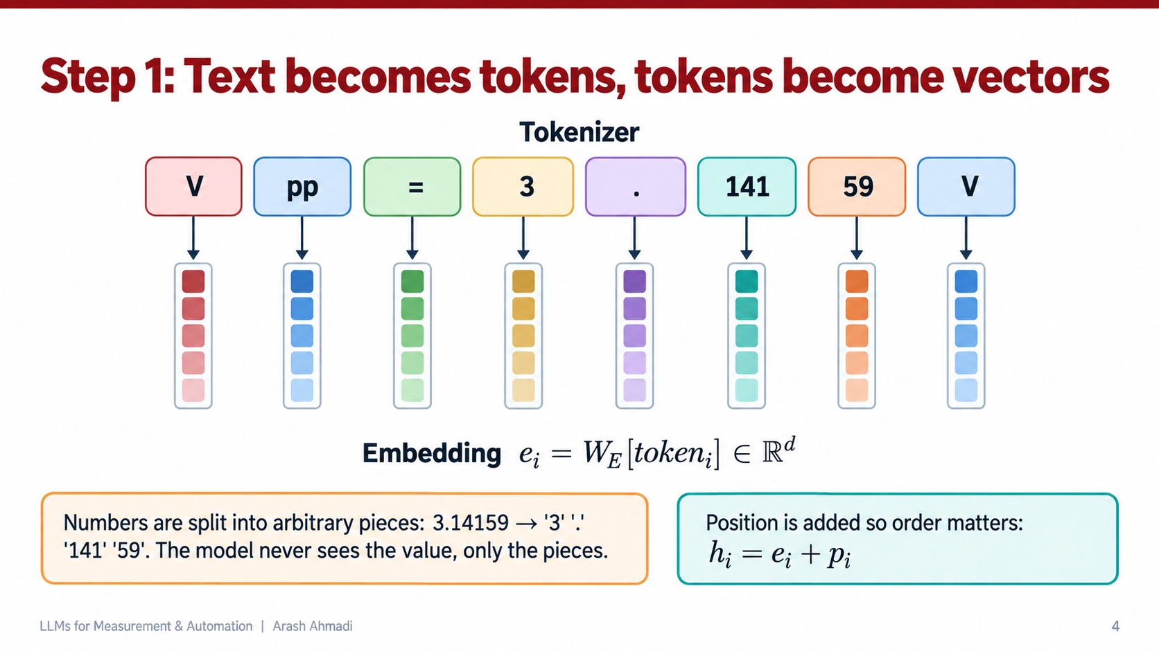
So how does text get into the model? A neural network only understands numbers, not letters. There are two steps.
The first step is the tokenizer. It cuts the text into tokens using a fixed vocabulary that was learned before training. Look at the example: "Vpp = 3.14159 V." The tokenizer cuts it into pieces: "V", "pp", the equals sign, "3", the decimal point, "141", "59", and "V."
Look closely at what happened to the number. The value 3.14159 did not become one number. It became four pieces of text: "3", the dot, "141", and "59." Those splits are not based on math at all. They are based on which character groups were common in the training text. This is the first surprise for engineers: the model never receives the value of your measurement. It only receives pieces of digits. Keep that in mind, because it comes back several times today.
The second step is the embedding. Each token has an ID number, and the model keeps a big table called the embedding matrix, written W with subscript E. Each token ID picks one row of that table. That row is a vector of d numbers, where d is often several thousand. So the equation says: the embedding e for token i is the row of W E that belongs to that token, and it lives in a space of d real numbers. The little columns of colored squares in the picture are these vectors.
One more detail, on the bottom right. The model also needs to know the order of the tokens, because "the gain is 3" and "3 is the gain" contain the same tokens in a different order. So we add a position vector p to each embedding. The result h equals e plus p is what actually enters the network. From here on, everything is matrix math on these vectors.

Slide 5: Attention, the core equation [4 minutes]
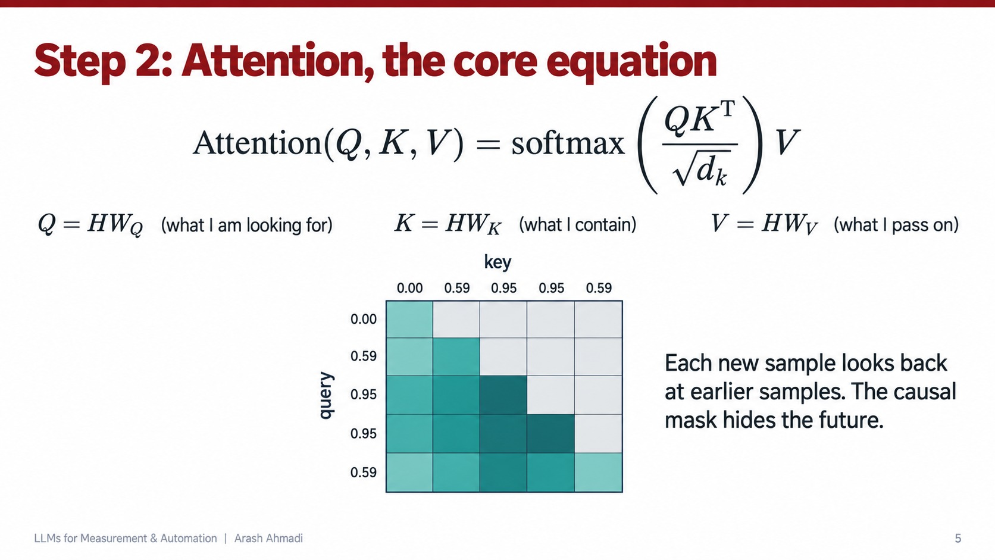
This slide is the heart of the modern language model. The mechanism is called attention, and the equation at the top is the one you will see in almost every paper since 2017.
Let me explain it in plain words first. Each token needs to collect information from the other tokens. For example, when the model reads the word "it" in a sentence, it needs to find out what "it" refers to. Attention is how each token decides which other tokens to look at and how much to take from each one.
To do that, every token creates three vectors from its hidden state H with three learned matrices. The query, Q equals H times W Q, means "what am I looking for." The key, K equals H times W K, means "what do I contain." The value, V equals H times W V, means "what I will pass on if someone looks at me."
Now read the equation from the inside out. Q times K transposed compares every query with every key using a dot product. A large dot product means a good match. That gives us a table of scores, one for every pair of tokens. We divide the scores by the square root of d k, the length of the key vectors. This keeps the numbers from getting too large, because very large scores make the softmax saturate and training becomes unstable. The softmax turns each row of scores into weights that add up to one. Finally we multiply by V, so each token receives a weighted average of the values of the tokens it attends to.
Now look at the heat map at the bottom. I used the samples of our sine wave as the tokens: 0.00, 0.59, 0.95, 0.95, 0.59. Each row is a query and each column is a key. Darker teal means more attention. Notice that the upper right triangle is gray. That is the causal mask. When the model predicts the next sample, it is only allowed to look at samples that came before, never at the future. That is exactly the rule you would want for any forecaster working on a measurement: you cannot use tomorrow's data to predict tomorrow.

Slide 6: Stack it, then learn it [3 minutes]
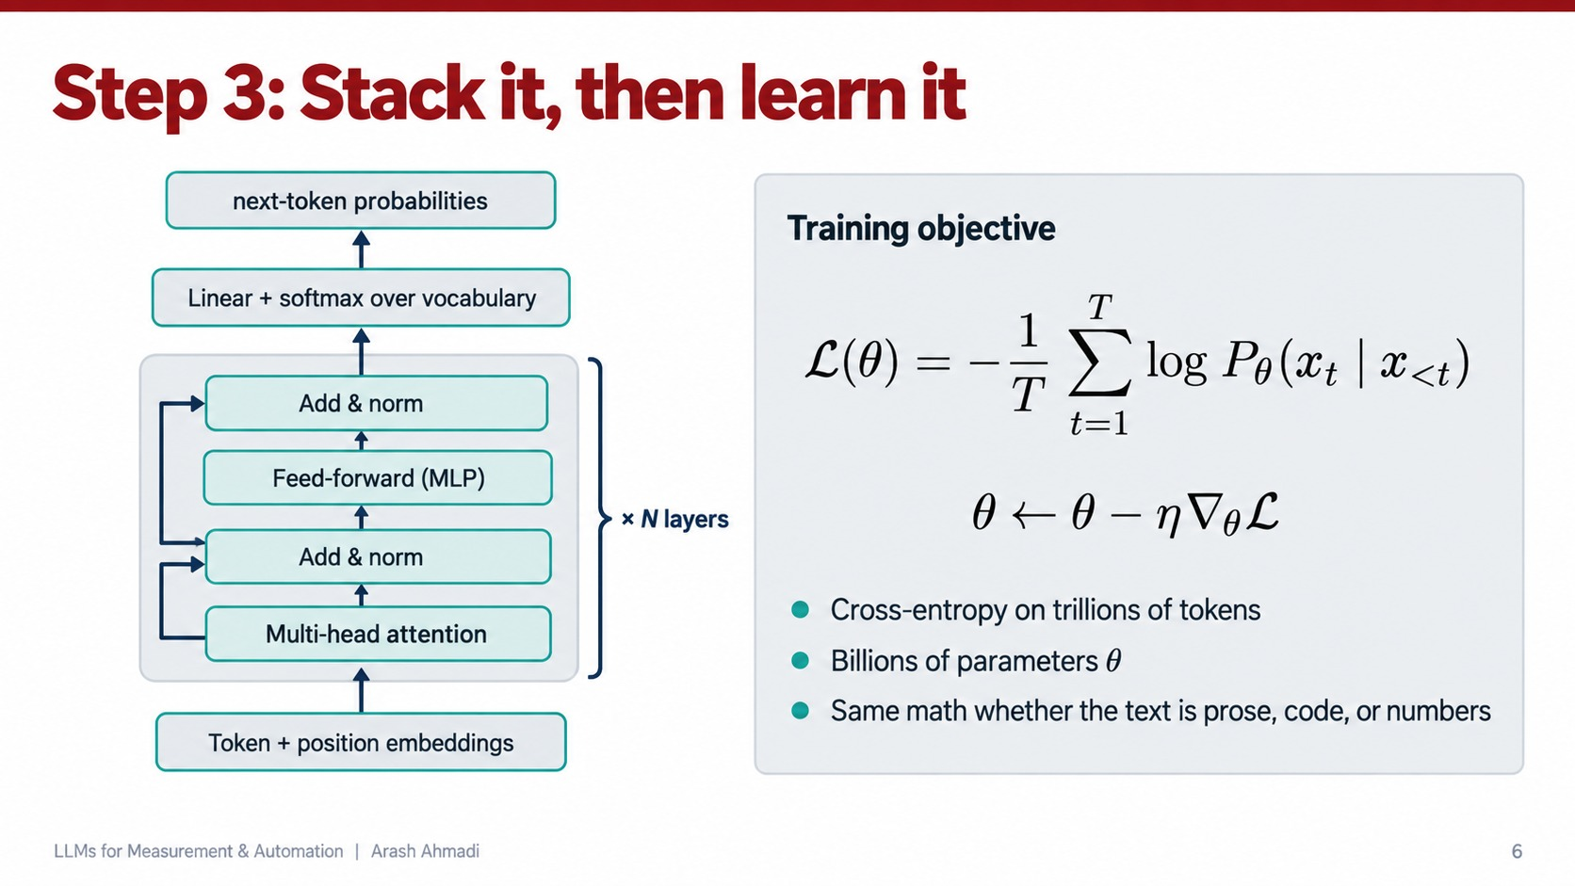
One attention layer is not enough, so we stack many of them. On the left is one transformer block. Tokens and positions come in at the bottom. They go through multi head attention, which is simply several attention operations running side by side, each free to focus on a different kind of relationship. Then comes an "add and norm" step. The arrows on the side are called residual connections: we add the input of each step back to its output, which lets information and gradients flow easily through very deep networks. After that comes a small feed forward network, sometimes called an MLP, applied to each token separately, and another add and norm. That whole block is repeated N times, often dozens of times. At the very top, a final linear layer and a softmax produce the next token probabilities we saw on slide 3.
So how does the model learn all those matrices? That is the right side. The training objective, written L of theta, is the cross entropy loss. In words: for every position in a huge amount of text, look at the probability the model gave to the token that actually came next, take the log, and average the negative of that over the whole sequence. If the model gave the true next token a high probability, the loss is small. If it was surprised, the loss is large.
The second line is gradient descent, which some of you have seen in other classes. Theta is the collection of all the parameters. We compute the gradient of the loss with respect to theta and take a small step, of size eta, in the opposite direction. Repeat that over trillions of tokens and you get a model with billions of parameters.
The last point on this slide matters for us. The math is the same whether the text is an essay, Python code, or a list of voltages. The model has no special machinery for numbers. That leads us directly to the sine wave.

Slide 7: How an LLM sees a measurement: the sine wave [4 minutes]
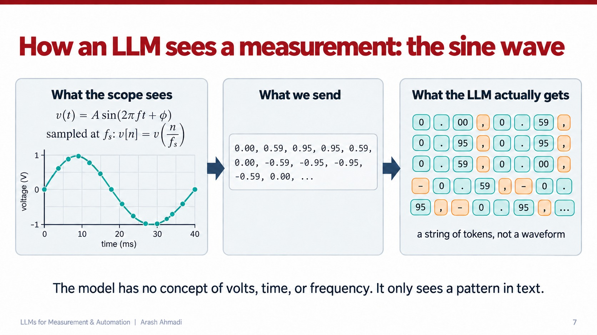
This is the slide I most wanted to show you. Let us follow a real measurement into the model.
The left panel is what your oscilloscope sees. The signal is v of t equals A times the sine of two pi f t plus phi, where A is the amplitude, f is the frequency, and phi is the phase. In this plot the amplitude is 1 volt and one full cycle takes 40 milliseconds, so the frequency is 25 hertz. The instrument does not store the continuous curve. It samples it at a sampling rate f s, so we get a list of numbers, v of n equals v of n divided by f s. Those are the dots on the curve. Everything you learned about sampling in this class still applies here.
The middle panel is what we send to a language model. There is no oscilloscope input on a chatbot, so we write the samples as text: 0.00, 0.59, 0.95, 0.95, 0.59, 0.00, minus 0.59, and so on.
The right panel is what the model actually receives, and this is the key point. The tokenizer cuts that text into pieces: "0", the dot, "59", a comma, a minus sign, and so on. Each voltage becomes several tokens, and the commas and minus signs become tokens as well. The model receives a string of tokens, not a waveform.
So think about what we lost. The model does not know these numbers are volts. It does not know the sample rate, so it cannot know the frequency in hertz. It does not know how precise the numbers are. It does not even know that 0.59 and 0.60 are close to each other, because as text they are just different pieces. The sentence at the bottom says it plainly: the model has no concept of volts, time, or frequency. It only sees a pattern in text.
Question for you: if you had to send this signal to a model as text, what would you add to make its job easier? The answer is the units, the sample rate, and a fixed number of digits. We will come back to that.

Slide 8: In context learning: the LLM continues the wave [3 minutes]
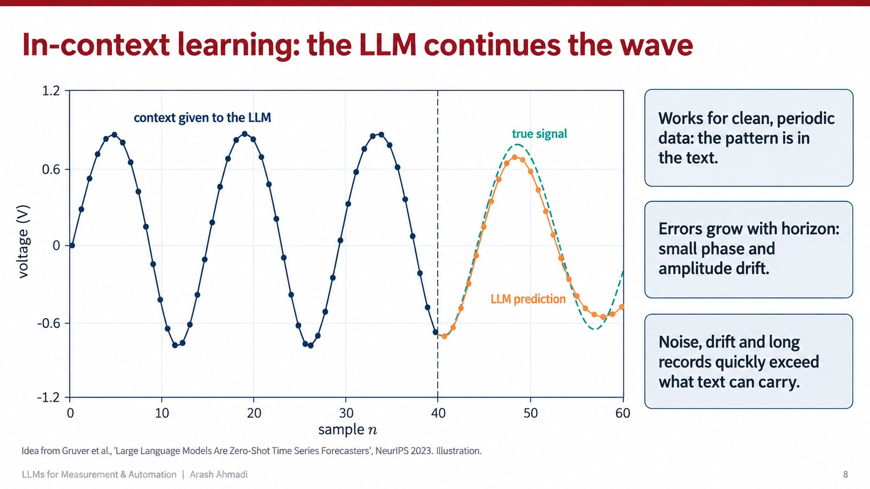
Now the surprising part. Even with all those limitations, if you paste the samples of a clean sine wave into a large model and ask it to continue the list, it often does a good job.
Look at the plot. The navy curve, samples 0 to 40, is the context we gave the model. After the dashed line, the teal dashed curve is the true signal and the orange dots are what the model predicted. For the first cycle the prediction follows the true wave closely. Toward the end it drifts a little in amplitude and in phase.
This ability is called in context learning. Nobody trained the model on this particular sine wave. It simply recognizes a repeating pattern in the text and continues it, the same way it would continue a repeating pattern in a poem. A group of researchers studied this carefully in a paper called "Large Language Models Are Zero Shot Time Series Forecasters," by Gruver and colleagues, presented at NeurIPS in 2023. They showed that when you format the numbers carefully, general language models can forecast simple time series without any special training.
But look at the three cards on the right. It works for clean periodic data, because the pattern really is in the text. The error grows the further ahead you predict, as you can see in the small drift. And real measurements have noise, drift, and very long records, which quickly go beyond what text can carry. So this is pattern completion on text. It is not signal processing, and you should not replace your FFT with it.

Slide 9: Four ways to give measurements to a model [3 minutes]
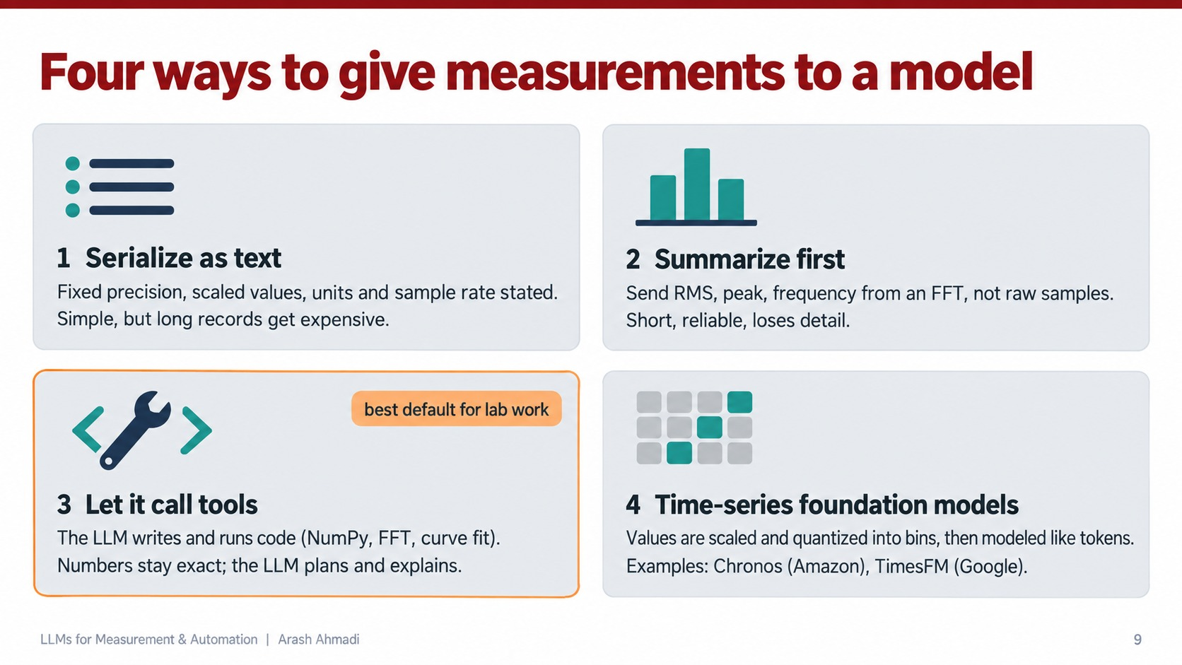
So if you want to use a language model with real measurement data, what are your options? Here are four.
Option one, serialize the data as text, like we just did. If you do this, use a fixed precision, scale the values to a sensible range, and state the units and the sample rate. It is simple, but long records get expensive, because every sample costs several tokens.
Option two, summarize first. Instead of sending ten thousand raw samples, compute the RMS value, the peak, and the dominant frequency from an FFT, and send only those numbers. That is short and reliable, but you lose detail.
Option three, let the model call tools. Here the language model does not read the numbers at all. It writes a short program, for example with NumPy, runs the FFT or a curve fit, and reads the result. The numbers stay exact because the computer computes them. The model plans the analysis and explains the result. This is highlighted because I think it is the best default for lab work.
Option four, use time series foundation models. These are models trained directly on signals instead of on text. Two known examples are Chronos from Amazon and TimesFM from Google. Chronos, for example, scales your values and then quantizes them into bins, so every bin acts like a token in a vocabulary made for signals instead of words. These can be very good at forecasting, but they do not write code or explain anything.

Slide 10: Case study: when the numbers in the prompt disagree [3 minutes]
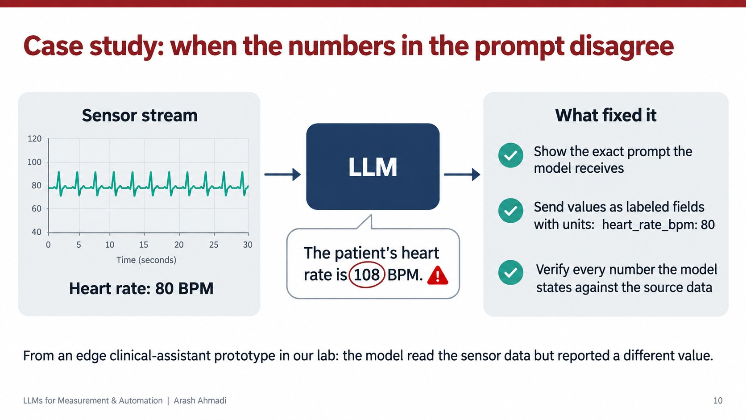
Let me give you a real example from our own lab, because it shows the risk better than any theory.
We built a prototype of a small clinical assistant that runs on an edge device. It reads a stream of sensor data such as heart rate, and a language model answers questions about the patient. On the left you can see the sensor stream. The heart rate is steady at about 80 beats per minute.
We asked the model about the patient, and it answered with confidence: "The patient's heart rate is 108 BPM." That number was simply wrong. When we investigated, the sensor data really was in the prompt. The model read the right data and still reported a different number.
Here is what fixed it, on the right. First, we added a view that shows the exact prompt the model receives, so anyone can see what data went in. Second, we stopped sending loose text and sent labeled fields with units, like "heart underscore rate underscore bpm colon 80." A clear label and a unit make it much harder for the model to confuse one number with another. Third, and most important, we verify every number the model states against the source data before anyone sees it.
The lesson for your measurements is direct. A language model can read the right number and still report a wrong one. It sounds just as confident when it is wrong as when it is right. So any number that matters must be checked by code against the real measurement.

Slide 11: LLMs that run instruments: the agent loop [3 minutes]
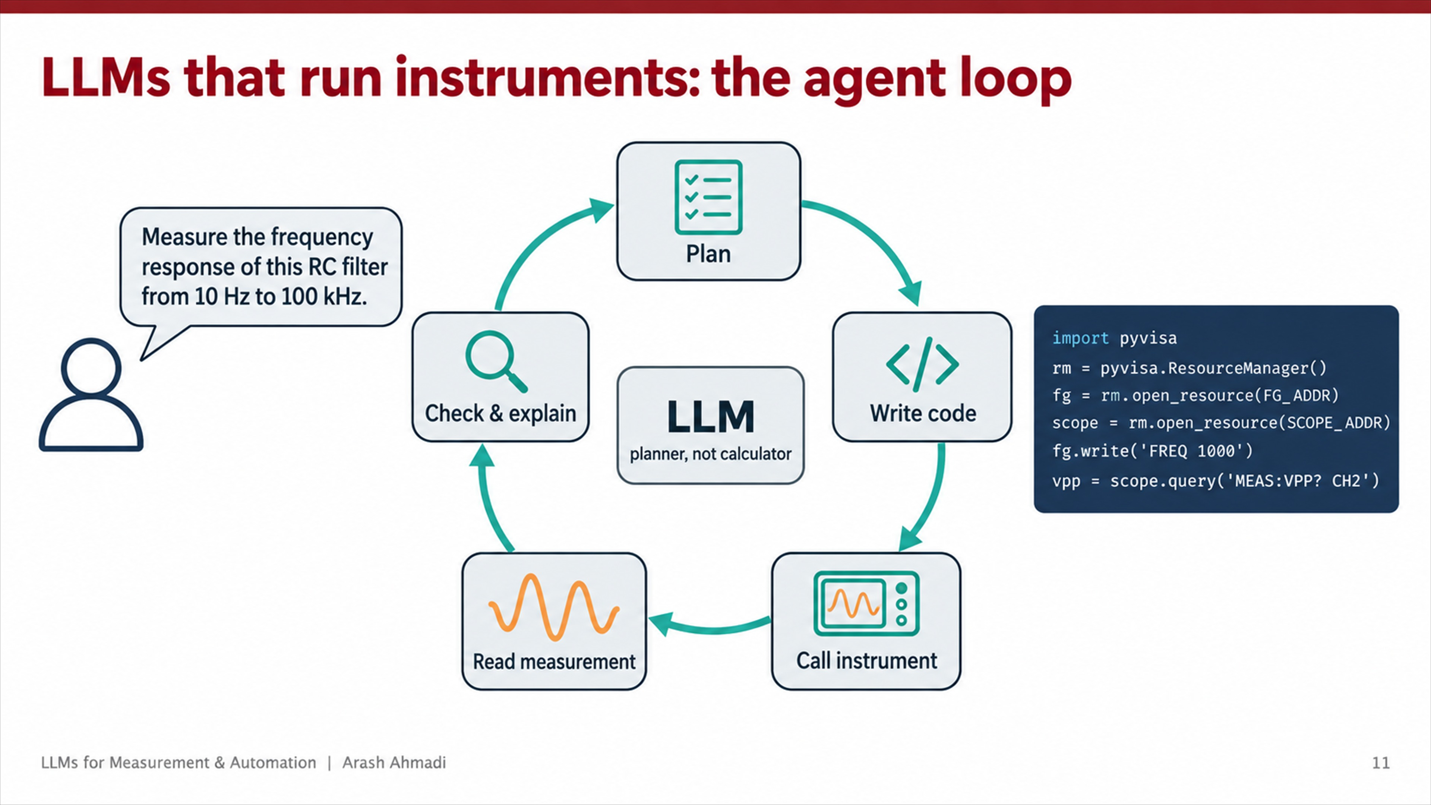
Now the more exciting part: automation. So far the model has been reading data. What if it could actually run the experiment?
A language model connected to tools is usually called an agent. Look at the loop in the middle. The user on the left gives a request in plain English: "Measure the frequency response of this RC filter from 10 hertz to 100 kilohertz." The agent then goes around the loop. It plans the experiment. It writes code. It calls the instruments. It reads the measurements. It checks the results and explains them. If something looks wrong, it goes back to planning and tries again.
Notice the label in the center: the language model is a planner, not a calculator. It decides what to do and writes the code, but the instruments do the measuring and the code does the math.
On the right is the kind of code the agent writes. It uses PyVISA, a Python library that talks to lab instruments over USB, GPIB, or Ethernet. It opens a resource manager, connects to the function generator and the oscilloscope by their addresses, sets the generator frequency to 1000 hertz, and asks the scope for the peak to peak voltage on channel 2. Those string commands, like "FREQ 1000," follow a standard instrument language called SCPI. The exact command names depend on the instrument model, so the agent needs the programming manual, just like you do.

Slide 12: Example: an RC low pass filter, measured by an agent [4 minutes]
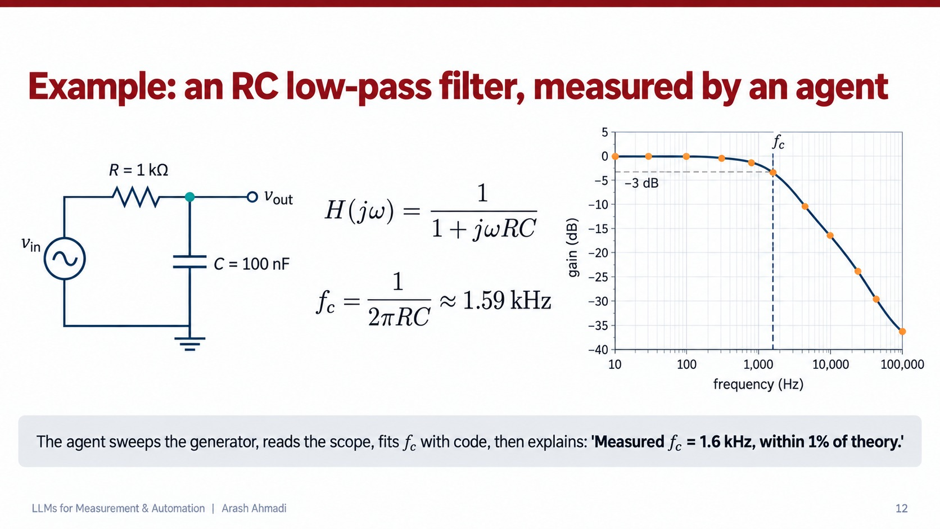
Let us make this concrete with a circuit you can check by hand. On the left is an RC low pass filter: a 1 kilo ohm resistor in series and a 100 nanofarad capacitor to ground, and we take the output over the capacitor.
The transfer function is H of j omega equals 1 over 1 plus j omega R C. At low frequency, j omega R C is tiny, so H is about 1 and the signal passes. At high frequency, the denominator grows, so the output falls. The cutoff frequency is where the magnitude drops to 1 over the square root of 2, which is minus 3 decibels. That happens at f c equals 1 over 2 pi R C. Plug in the numbers: R times C is 1000 times 100 times 10 to the minus 9, which is 10 to the minus 4 seconds. One over 2 pi times 10 to the minus 4 is about 1.59 kilohertz.
The plot on the right is a Bode magnitude plot. The navy curve is the theory and the orange dots are the measured points. Below about 200 hertz the gain is flat at 0 dB. At 1.59 kilohertz it crosses minus 3 dB, marked by the dashed lines. Above the cutoff it falls at 20 dB per decade, which is the signature of a first order filter: minus 16 dB at 10 kilohertz and minus 36 dB at 100 kilohertz.
Now here is what the agent does. It sweeps the function generator through the frequency range, reads the input and output amplitudes from the scope at each point, and computes the gain in decibels. Then it fits the cutoff frequency with code, not in its head. Finally it writes the explanation: "Measured f c equals 1.6 kilohertz, less than 1 percent away from theory." That is a real result you could get on your bench, and every number in that sentence came from a measurement and a fit, not from the model's memory.

Slide 13: Where this fits with PLCs, LabVIEW and your bench [3 minutes]
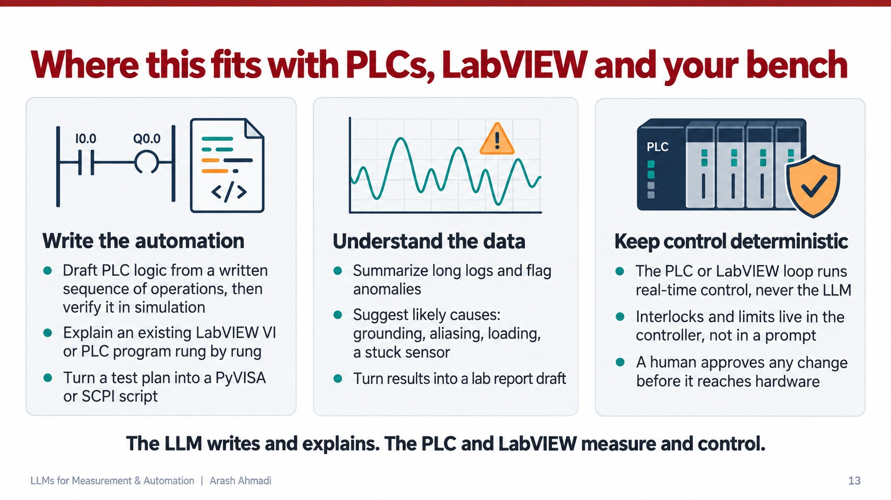
How does this connect to what you do in this class? You spend half the semester on PLCs and half on LabVIEW, so let me place the language model next to both. I see three roles.
The first column is writing the automation. You can give a model a written sequence of operations, for example: when the start button is pressed and the guard is closed, run the conveyor until the sensor sees a part. Then you ask it to draft the PLC logic. You still read every rung yourself and test it in simulation before it goes near a machine. You can also hand it an existing LabVIEW VI or a PLC program and ask it to explain it block by block or rung by rung, which is very helpful when you inherit someone else's project. And it can turn a test plan into a Python script with PyVISA or SCPI commands.
The second column is understanding the data. A model is good at reading a long log and flagging the parts that look unusual. It can suggest likely causes for a strange measurement: a grounding problem, aliasing because the sample rate is too low, loading because your probe or your next stage changes the circuit, or simply a stuck sensor. It can also turn your results into a first draft of a lab report, which you then check and correct.
The third column is the most important one for this class: keep control deterministic. A PLC runs its program in a fixed scan cycle. It reads every input, runs the logic, and writes every output, often every few milliseconds, and it does exactly the same thing every time. A language model takes seconds to answer, and it can give a different answer to the same question. So the real time control loop always stays in the PLC or in LabVIEW, never in the language model. Interlocks and limits, like the maximum voltage or the rule that a press cannot move while the guard is open, live in the controller and not in a prompt. And a human approves any change before it reaches the hardware.
The sentence at the bottom sums it up. The language model writes and explains. The PLC and LabVIEW measure and control.
But there is a newer kind of model that sits in between these two worlds, and it matters a lot for automation. That is the next slide.

Slide 14: The middle ground: fast decision models [3 minutes]
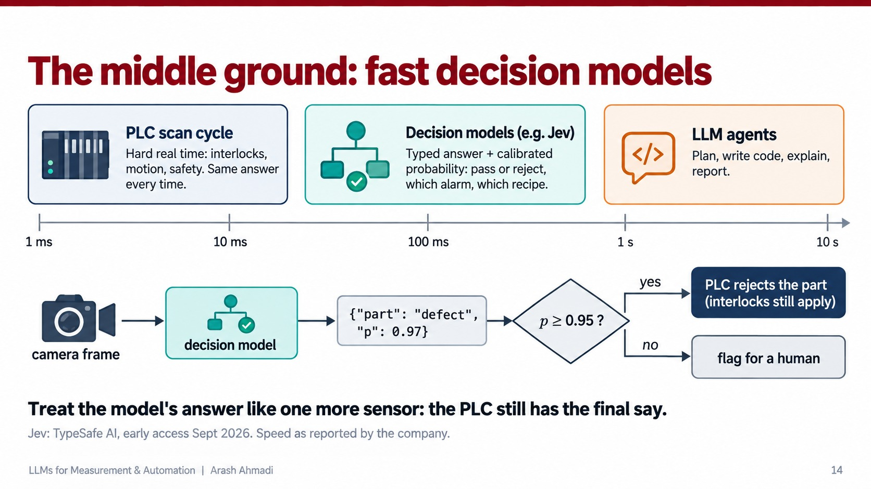
I just told you the language model never runs the control loop. That is true for chat models, but a newer kind of model sits in between.
Look at the timescale at the top. On the left, at around one to twenty milliseconds, is the PLC scan cycle. That is hard real time: interlocks, motion, safety, and the same answer every time. On the right, at seconds, are the language model agents we have discussed. They plan, write code, and explain. In the middle, between about 70 and 500 milliseconds, is a new class of models called decision models. One example is Jev, which a company called TypeSafe AI released in early access this September. A decision model does not write sentences. You give it the input and a fixed list of allowed answers, for example pass or reject, and it returns one answer together with a probability. The company trains these probabilities to be calibrated. That means when the model says 0.97, it should be right about 97 percent of the time. The speed numbers come from the company itself, so treat them as claims until someone reproduces them.
Now look at the example at the bottom. It is a machine vision station, like the ones you build in this course. The camera takes a frame, the decision model looks at it, and it answers: this part has a defect, with probability 0.97. Then a simple rule decides what happens. If the probability is at least 0.95, the PLC rejects the part. If it is lower, the part goes to a human for a second look.
The important design choice is the sentence at the bottom. We treat the model's answer like one more sensor. The PLC still runs the loop, and the interlocks still apply. If the model is wrong, the worst case is a part in the wrong bin or an extra check by a person. The model alone can never make a machine move when it should not.

Slide 15: Pitfalls you will actually hit [3 minutes]
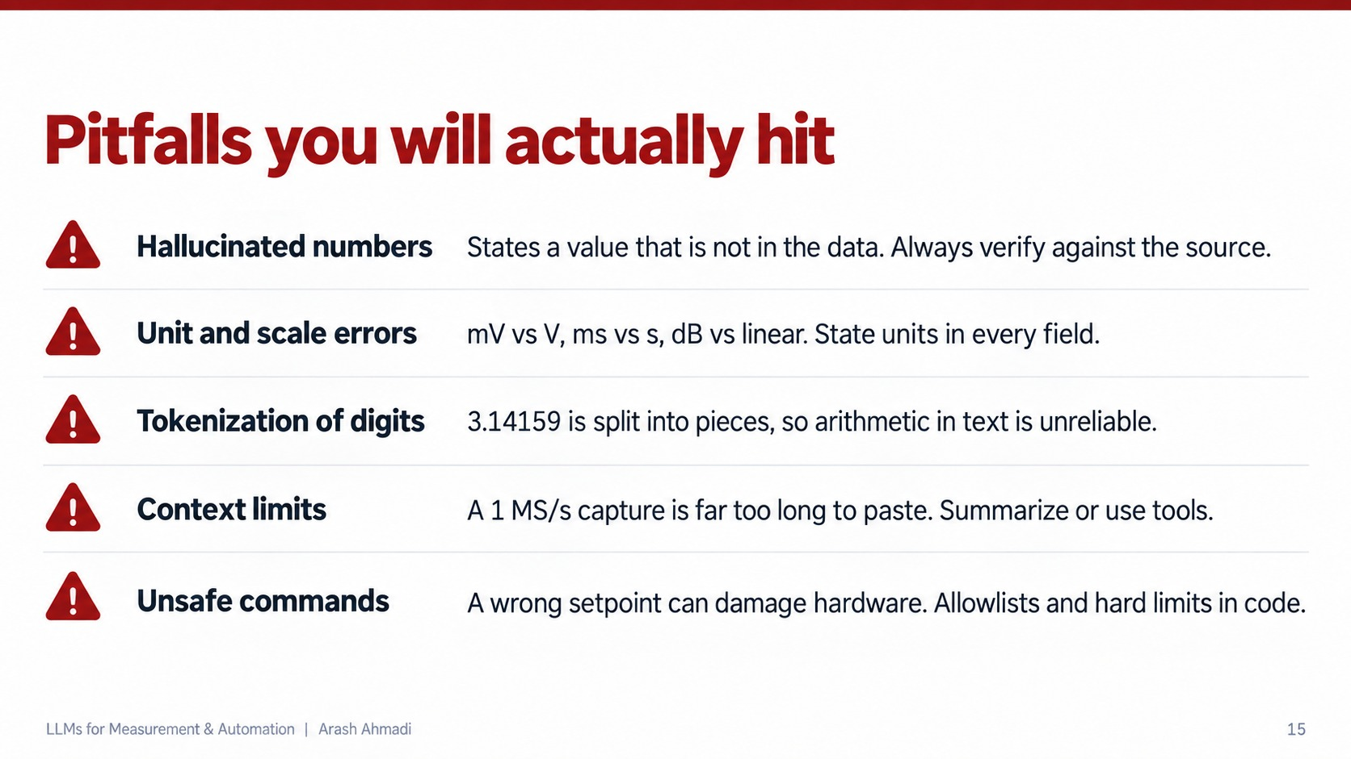
If you start using these models in the lab, these are the five problems you will actually run into.
First, hallucinated numbers. The model states a value that is not in the data at all, like our 108 beats per minute. The fix is to always verify against the source.
Second, unit and scale errors. Millivolts versus volts, milliseconds versus seconds, decibels versus a linear ratio. A factor of a thousand looks very small in text. The fix is to state the unit in every single field you send.
Third, tokenization of digits. Remember that 3.14159 is split into pieces. That is why a language model can be unreliable at arithmetic when it does the arithmetic in text. The fix is to let code do the math.
Fourth, context limits. A model can only read a limited amount of text at once, called its context window. A capture at 1 megasample per second gives you a million numbers every second, which is far too long to paste into a prompt. The fix is to summarize or use tools.
Fifth, unsafe commands. If an agent sends a wrong setpoint to a power supply, it can damage your device under test or the instrument itself. The fix is an allowlist of permitted commands and hard limits enforced in code, so the model is physically unable to send something dangerous.

Slide 16: A checklist for using LLMs with measurements [2 minutes]
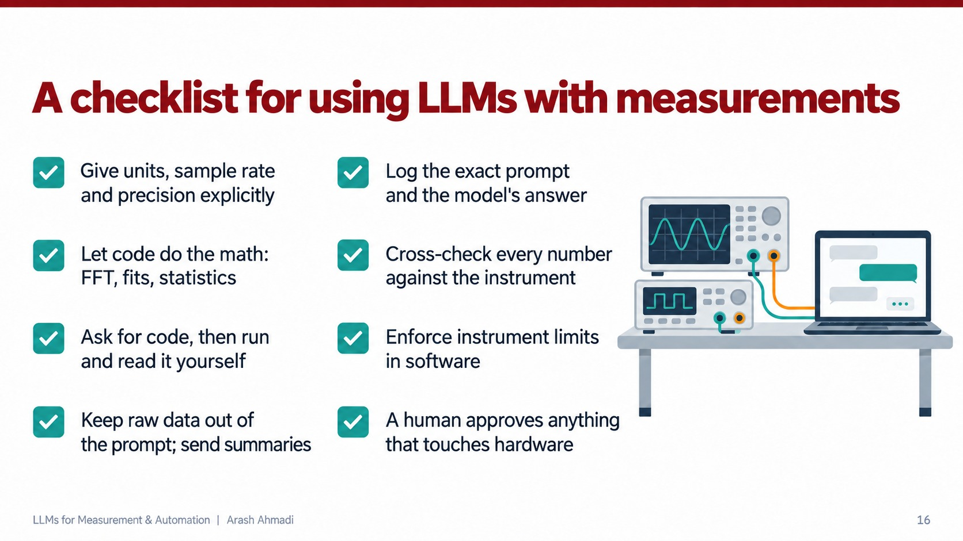
Here is a checklist you can take home. Give units, sample rate, and precision explicitly. Let code do the math: the FFT, the fits, and the statistics. Ask the model for code, then run it and read it yourself. Keep raw data out of the prompt and send summaries instead. Log the exact prompt and the model's answer, so you can find out later what went wrong. Cross check every number against the instrument. Enforce instrument limits in software. And a human approves anything that touches hardware.
Think about the last lab you did. Which of these would you have skipped? If you are honest, it is probably the logging, and that is exactly the one that saves you when something goes wrong.

Slide 17: Summary [1.5 minutes]
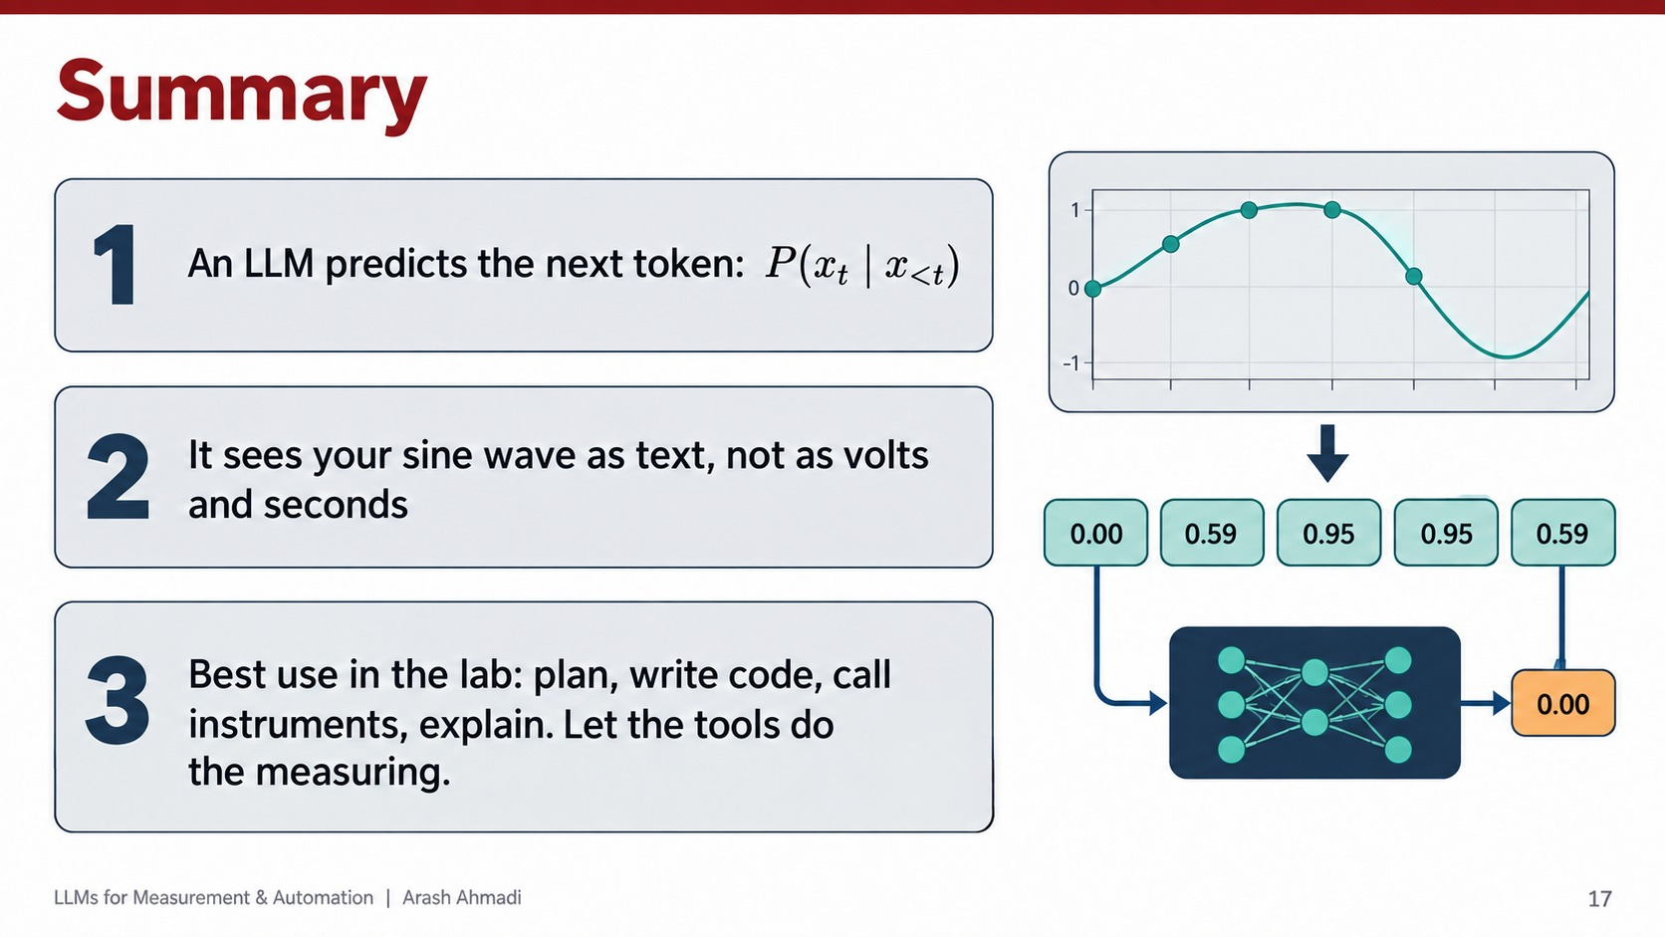
Let me bring it all together in three sentences.
One: a language model predicts the next token, P of x t given everything before it. Every behavior you see comes from that single loop.
Two: it sees your sine wave as text, not as volts and seconds. It can continue a clean pattern, but it does not understand the physics, the units, or the time base unless you give them to it, and it can misread numbers even when they are right there.
Three: the best use in the lab is to let it plan, write code, call instruments, and explain. Let the tools do the measuring.

Slide 18: Questions, and join the LLM Engineering Club [remaining time]
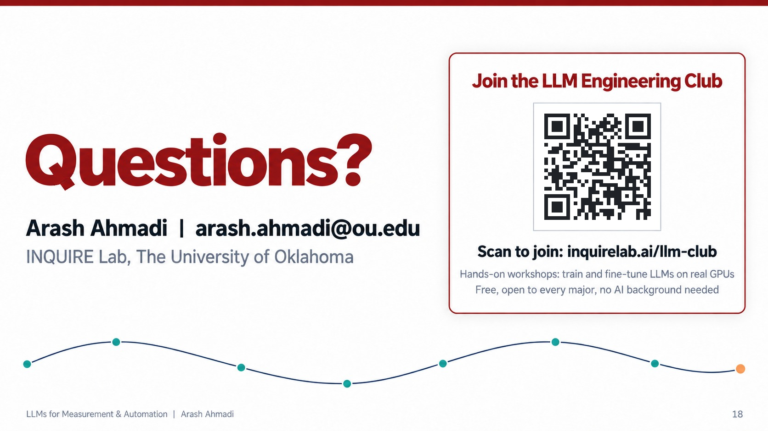
Thank you all for your attention, and thank you again to Dr. Sharif for having me.
Before we start the questions, look at the card on the right. If today made you curious, I would love to see you at the LLM Engineering Club. It is an official student organization here at OU, and it is free to join. In our workshops we do exactly what we talked about today, with our own hands: we train and fine tune language models on real GPUs, we build agents, and we test where they fail. You do not need any background in AI, and every major is welcome. Scan the QR code, or go to inquirelab dot ai slash llm dash club, and you can join from there.
Now I am happy to take any questions, whether about the math, the sine wave example, or how to try this on your own bench. If you want the slides or the example code later, you can reach me at arash dot ahmadi at ou dot edu.

